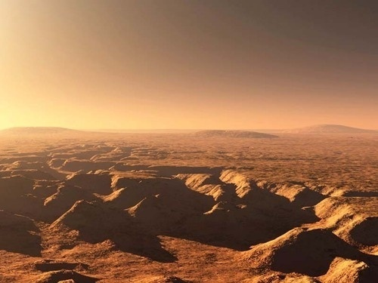 Crashed on Mars
Purpose: This lesson stimulates critical thinking about what life might be like on other planets and sets the stage for a brief study of the environment on other planets.
Objectives: Students will be able to:
- Compare and contrast the environments of Mars and Earth.
- Give practical examples of how these differences might affect daily activities on Mars.
Materials
- pencils
- paper
- list of survival equipment
Activities and Procedures
Day 1 – Research/ Compare and contrast Earth and Mars
- Compare and contrast after extensive research some of the major environmental differences between Earth and Mars.
- Create a double bubble map to compare and contrast the environmental differences found on Earth and Mars. Then give examples of how each difference might affect your life if you were living on Mars.
Examples of some major factors:
  - Atmospheric Pressure
  - Temperature
  - Weather
  - Gravity
  - Organisms
  - Oxygen available
  - Crustal activity--quakes, volcanoes, movement

Day 2 and 3 – Group activity
- Make a list of how these differences might affect daily activities on Mars.
- Class will be divided into groups. Each group will designate a time keeper to keep your group on task, a reader to read and explain the reports, a recorder to write down the items you should/should not bring and the reasons and a note taker. All students in the group should be responsible for research.
- Your group is the crew on a spaceship that is about to crash on the Mars.
- Prepare a script and read the prepared script describing the "CRASH" on Mars. You could also create a movie or skit, complete with a space ship, background music, and a narrator.
- Following the crash, an announcement is made that the spaceship is disabled, the radio is broken, and nearest base is 50 km away. Each group must get to the base with no outside help.
- The task is to decide as a group which emergency supplies from their disabled spaceship to take with you. You are to list the supplies in order of priority and state why you chose each item. Below is a partial list-
    - First Aid Kit
    - Water
    - Freeze dried food
    - 50 feet of rope
    - Parachute
    - Inflatable Raft
    - Small backpack Stove
    - Stove Fuel
    - Matches
    - Standard backpack tent
    - Sleeping Bags
    - Pressure Suits
    - Extra oxygen cylinders compatible with pressure suits
    - Compass
    - Map of Mars
    - Suit repair kit
    - Flashlight
Day 4
- Each group reports on their list and why they chose each item.

